PRM393 – SE1909
Đặng Đức Minh – SA170080
Lab 2:
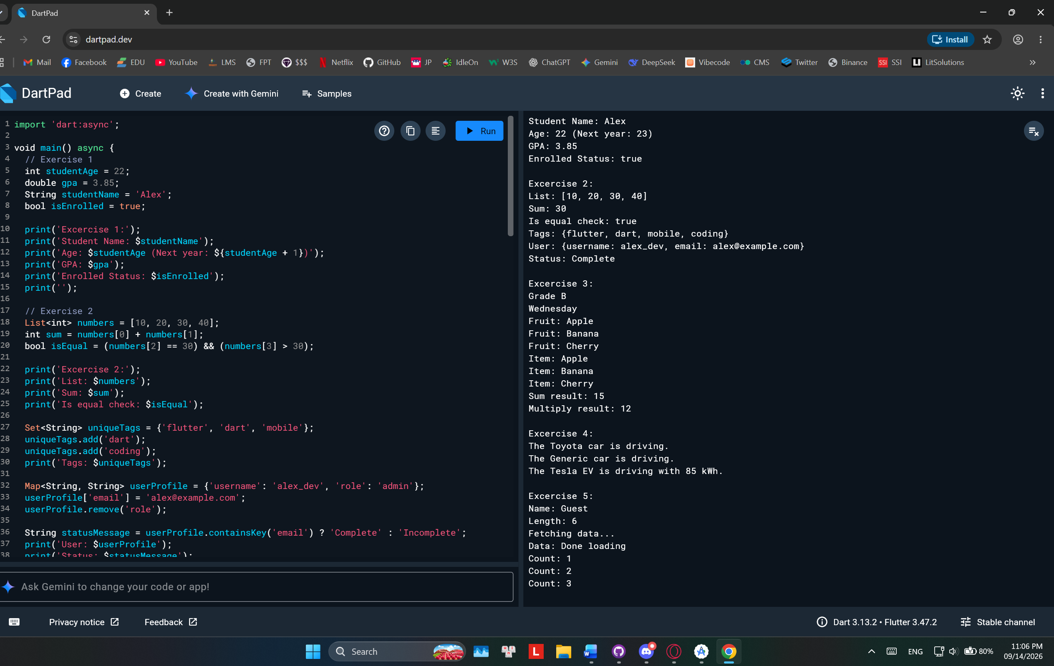import 'dart:async';

void main() async {
// Exercise 1
int studentAge = 22;
double gpa = 3.85;
String studentName = 'Alex';
bool isEnrolled = true;

print('Excercise 1:');
print('Student Name: $studentName');
print('Age: $studentAge (Next year: ${studentAge + 1})');
print('GPA: $gpa');
print('Enrolled Status: $isEnrolled');
print('');

// Exercise 2
List<int> numbers = [10, 20, 30, 40];
int sum = numbers[0] + numbers[1];
bool isEqual = (numbers[2] == 30) && (numbers[3] > 30);

print('Excercise 2:');
print('List: $numbers');
print('Sum: $sum');
print('Is equal check: $isEqual');

Set<String> uniqueTags = {'flutter', 'dart', 'mobile'};
uniqueTags.add('dart');
uniqueTags.add('coding');
print('Tags: $uniqueTags');

Map<String, String> userProfile = {'username': 'alex_dev', 'role': 'admin'};
userProfile['email'] = 'alex@example.com';
userProfile.remove('role');

String statusMessage = userProfile.containsKey('email') ? 'Complete' : 'Incomplete';
print('User: $userProfile');
print('Status: $statusMessage');
print('');

// Exercise 3
int score = 88;
print('Excercise 3:');
if (score >= 90) {
print('Grade A');
} else if (score >= 80) {
print('Grade B');
} else {
print('Grade C');
}

int dayOfWeek = 3;
switch (dayOfWeek) {
case 1:
print('Monday');
break;
case 3:
print('Wednesday');
break;
default:
print('Other day');
}

List<String> fruits = ['Apple', 'Banana', 'Cherry'];
for (var fruit in fruits) {
print('Fruit: $fruit');
}

fruits.forEach((item) => print('Item: $item'));

print('Sum result: ${calculateSum(5, 10)}');
print('Multiply result: ${multiply(4, 3)}');
print('');

// Exercise 4
print('Excercise 4:');
Car baseCar = Car('Toyota');
baseCar.drive();

Car defaultCar = Car.unknown();
defaultCar.drive();

ElectricCar myEV = ElectricCar('Tesla', 85);
myEV.drive();
print('');

// Exercise 5
print('Excercise 5:');
String? nullableName;
print('Name: ${nullableName ?? "Guest"}');

nullableName = 'Jordan';
print('Length: ${nullableName.length}');

print('Fetching data...');
String data = await fetchData();
print('Data: $data');

await for (int count in countStream(3)) {
print('Count: $count');
}
}

int calculateSum(int a, int b) {
return a + b;
}

int multiply(int a, int b) => a * b;

class Car {
String brand;

Car(this.brand);

Car.unknown() : brand = 'Generic';

void drive() {
print('The $brand car is driving.');
}
}

class ElectricCar extends Car {
int batteryCapacity;

ElectricCar(String brand, this.batteryCapacity) : super(brand);

@override
void drive() {
print('The $brand EV is driving with $batteryCapacity kWh.');
}
}

Future<String> fetchData() async {
await Future.delayed(Duration(seconds: 1));
return 'Done loading';
}

Stream<int> countStream(int max) async* {
for (int i = 1; i <= max; i++) {
await Future.delayed(Duration(milliseconds: 500));
yield i;
}
}

